TrafficTelligence:Advanced Traffic

Volume Estimation with Machine Learning

By

***(Vyshnavi)***

***(Keerthana )***

***(Maneesha)***

# A Dissertation Submitted to SRI VENKATESWARA COLLEGE OF ENGINEERING AND TECHNOLOGY, An

Autonomous Institution affiliated to ‘JNTU Ananthapur’ in Partial Fulfilment of the Bachelor of Technology (***Computer Engineering***) with Specialization in ***Artificial Intelligence and Machine***

***Learning.***

*May 2024*



**SRI VENKATESWARA COLLEGE OF**

**ENGINEERING AND TECHNOLOGY**

**R.V.S. Nagar Tirupathi Road, Andhra**

**Pradesh– 517127**

**Proposed Solution**

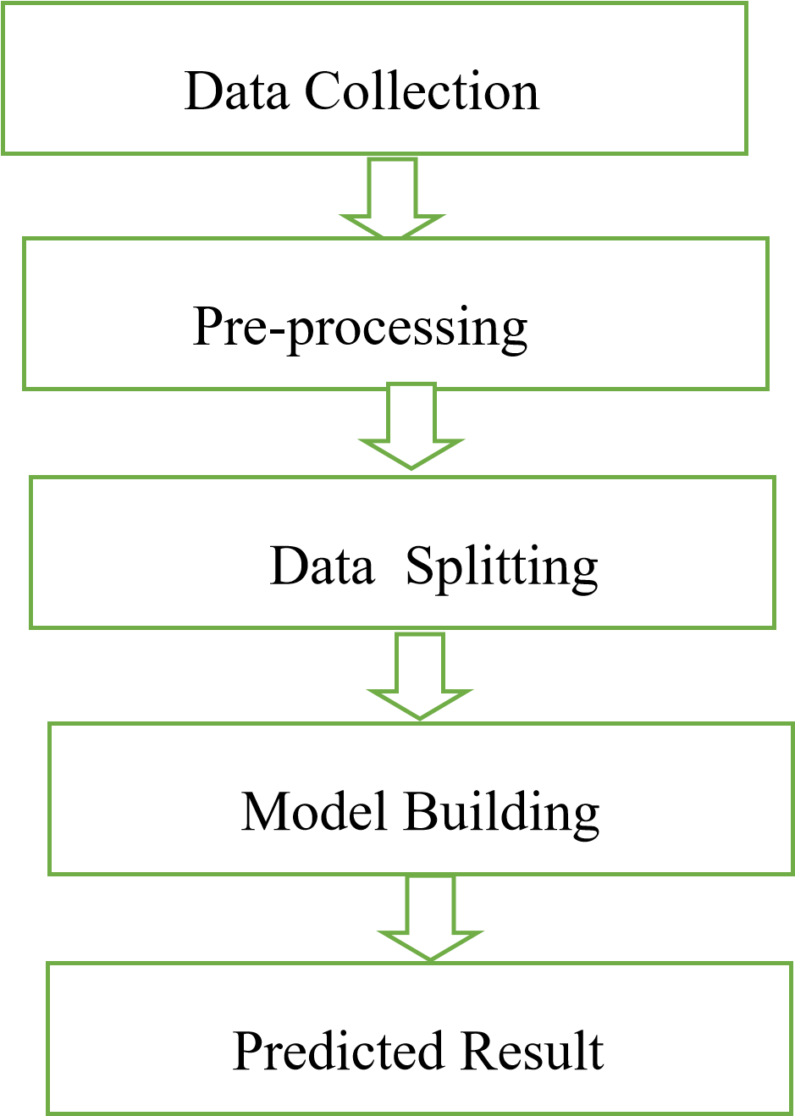

The system presented here composes of five modules:-

1. Input as Dataset
2. Pre processing 3. Data splitting
3. Build & Model
4. Output as Predicted Result

Attribute :Traffic congestion is a significant challenge in urban areas,leading to wasted time,increased fuel consumption,and environmental pollution.accurate estimation of traffic volume is essential for effective traffic management and urban planning. In this paper,we propose an advanced traffic volume estimation system leveraging machine learning techiniques.our apporoach utililizes deep learning models,specifically convolution neural networks(CNNs) and recurrent neural networks(RNNs),trained on historical traffic data to predict future traffic volume.we also explore the integration of realtime data sources such as traffic sensors and GPS devices to enhance prediction accuracy.The proposed solution aims to provide actionable insights for traffic management authorities to optimize traffic flow and reduce congestion

**1.Introduction:**

Traffic congestion is a pervasive problem in urban areas worldwide,causing economic losses,environment pollution,and reduced quality of life for residents.accurate estimation of traffic management agencies to implement effective strategies for congestion mitigation and urban planning.traditional methods of volume estiation,such as manual traffic counts and loop detectors,have limitations in terms of accuracy,scalability,and cost-effectiveness.in recent years,machine learning techniques have shown promise in predicting traffic volume with higher accuracy and efficiency.in this paper,we propose an advanced traffic volume estimation system utilizing machine learning algorithms,specially deep learning models.

**2.Literature Review :**

Preview research in traffic volume estimation has primarily focussed on traditional statistical methods and machine learning techniques.stasistical methods such as time series analysis and regression models have been widely used but often struggle to capture the complex temporal and spatial patterns inherent in traffic data.machine learning approaches,particularly deep learning models,have shown significant improvements in traffic volume prediction by leveraging the non-lineara relationships within the data.convolutional neural networks (CNNs)and recurrent neural networks(RNNs) have emerged as powerful tools for capturing spatial and temporal dependencies in traffic data,leading to more accurate predictions.

**3.Methodology**

**3.1 Data Collection:**

The first step in our approach is to collect historical traffic data from various sources,including traffic sensors,GPS devices,and public transportation agencies.This data typically includes information such as vehicle counts,spped,time of day,day of week, weather conditions,and road infastructure.byaggregating and preprocessing this data,we create a comprehensive dataset for training our machine learning models.

**3.2 Model Selection:**

We explore the use of both CNNs and RNNs for the traffic volume estimation.CNNs are well-suited for capturing spatial patterns in traffic data,sucha s traffic flow on road networks and congestion hotspots.RNNs,on the other hand,excel at modelling temporal dependencies, such as daily and weekly traffic patterns.by combining these two types of models,we aim to leverage their complementary strengths and improve prediction accuracy.

**3.3Model Training:**

We split the collecte data into training,validation,andtest sets for model training and evaluation.we experiment with different network architectures,hyperparameters,and training algorithms to optimize model performance.we also employ techniques such as data augmentation and regularization to prevent overfitting and improve generalization.

**3.4 Integration of Real time Data:**

In addition to historical traffic data,we integrate real-time data sources such as as live traffic feeds,weather updates,and event schedules into our prediction models.this allows us to to adapt our predictions in realtime to changing traffic conditions and external factors that may impact traffic volume.

**4.Experimental Results:**

We evaluate the performance of our traffic volume estimation system using various metrices such as mean absolute error(MAE),root mean square error(RMSE),and coefficient of determination(R^2).Our experiments demonstrate that the combined CNN-RNN Approach outperforms individual models and traditional statistical methods in terms of prediction accuracy and robustness.Furthermore,we show that incorporating real-time data leads to further improvements in prediction accuracy,especially during periods of high traffic variability.

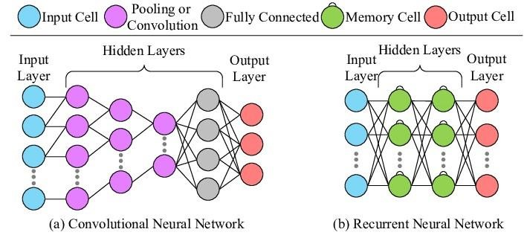

**5.Discussion:**

Our proposed solution offers several advantages over existing methods of traffic volume estimation.By leveraging deep learning models and real-time data integration,we can provide more accurate and timely predictions of traffic volume,enabling traffic management

Authorities to make informed decisions and make proactive measures to alleviate congestion.However,there are still challenges to overcome, such as data quality issues,model interpretability,and scalability of the system.Future research directions may include exploring alternative data sources, incorporating uncertainty estimation into prediction models,and developing scalable infrastructure for real-time data processing

**6.Conclusion:**

In conclusion, we have presented an advanced traffic volume estimation system based on machine learning techniques,specifically CNNs and RNNs.Our approach demonstrates superior prediction accuracy compared to traditional methods,especially when integrated with real time data sources.by providing accurate and timely predictions of traffic volume,our system can help improve traffic management and urban planning,leading to reduced congestion,enhanced mobility,and a better quality of life for urban residents.